FT-I Test
Academic Year: 2025-2026 (ODD Semester)

Program offered: M.Tech. (Electronics and Control Engineering) Year / Sem: I / I
Course Code/Title: 21EIE502T: Computer Vision System Date: 09.10.2025
Max. Marks: 40 Duration: 60 minutes

Course Articulation Matrix (CAM)

Course Outcomes (CO) | Program Outcomes (PO)
 | 1 | 2 | 3
CO1: Apply the knowledge to select the appropriate image processing tool for various applications. | 3
CO2: Ability to align the samples based on features and estimate the motion. | 3 |  | 2
CO3: Evaluate the performance of machine learning models for recognition and rendering applications. | 2 | 2 | 2

Answer any two questions (2*20 = 40 Marks)

S.No | Questions | CO | BL | Marks
1 | Illustrate how Fourier transforms can be used to solve filtering problems in image processing. Show how frequency domain operations can predict image enhancement results. | 1 | 3 | 20
2 | Apply point operators and histogram equalization to normalize brightness in an image with non-uniform illumination. Demonstrate the improvement with a suitable example. | 1 | 3 | 20
3 | Classify the differences between 2D and 3D feature-based alignment and categorize applications where each method is appropriate. | 2 | 4 | 20
4 | A camera undergoes translational motion. Analyse how optical flow can be used to estimate motion parameters in this case. | 2 | 4 | 20

- Illustrate how Fourier transforms can be used to solve filtering problems in image processing. Show how frequency domain operations can predict image enhancement results.

1. Introduction (4 Marks)
- Images can be represented in two domains:
  - Spatial domain → pixel values directly (row & column).
  - Frequency domain → how quickly pixel values change (edges, textures).
- Fourier Transform (FT) is the tool that converts an image from spatial domain to frequency domain.
Mathematically,
$$F(u,v)=\sum_{x}{}\sum_{y}{}f(x,y)e^{-j2π(ux/M+vy/N)}$$
where:
- $f(x,y)$= spatial image,
- $F(u,v)$= frequency spectrum.

2. Role of Fourier Transform (4 Marks)
- Breaks down an image into sinusoidal components of different frequencies.
- Low frequencies → smooth variations (background, illumination).
- High frequencies → rapid changes (edges, fine details, noise).
- Helps analyze and process images based on frequency content rather than pixel intensity.

- A Fourier transform (FT) rewrites an image as a sum of sinusoids of different frequencies and phases.
- In the frequency domain you see how quickly pixel values change across the image: slow changes = low frequency, rapid changes (edges, texture, noise) = high frequency.
- This separation makes many filtering operations conceptually and computationally simpler.

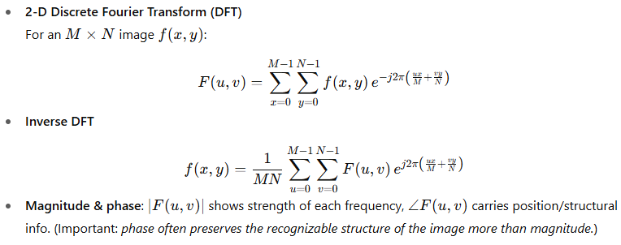
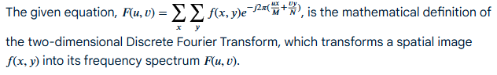

3. Why Frequency Domain Representation is Useful? (4 Marks)
- Some operations are easier in frequency domain than spatial domain.
- According to the Convolution Theorem:
  - Convolution in spatial domain ↔ Multiplication in frequency domain.
  - Filtering (blurring, sharpening, noise removal) becomes simple multiplication.

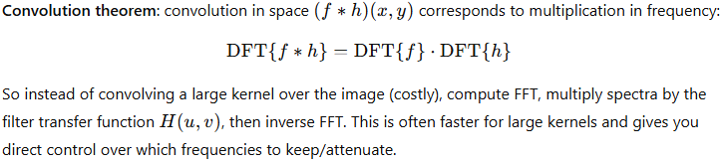

4. Filtering Operations (4 Marks)
- Low-pass filtering (LPF):
  - Keeps low frequencies, removes high frequencies.
  - Result: image smoothing or blurring.
- High-pass filtering (HPF):
  - Keeps high frequencies, removes low frequencies.
  - Result: edge enhancement, sharpening.
- Band-pass filtering:
  - Keeps only selected frequency ranges.
  - Useful for texture analysis.

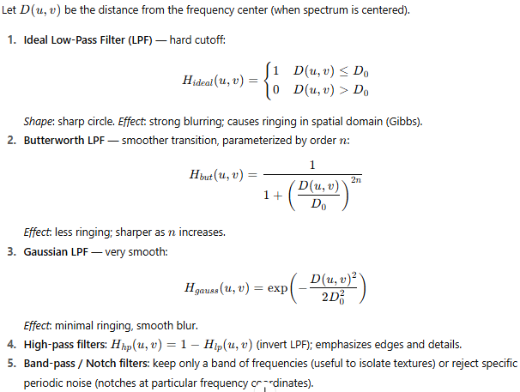

5. Practical Example (4 Marks)
- To remove noise: since noise is often high frequency, apply a low-pass filter.
- To sharpen edges: emphasize high frequencies using a high-pass filter.
- Medical imaging, satellite images, and fingerprint recognition all rely on Fourier-based filtering.

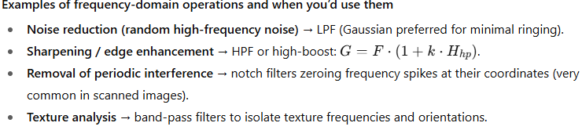

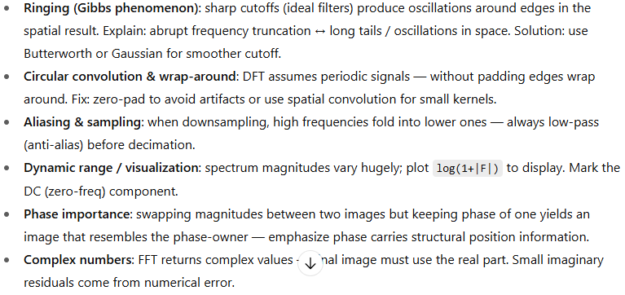

- Apply point operators and histogram equalization to normalize brightness in an image with non-uniform illumination. Demonstrate the improvement with a suitable example.

1. Introduction (2–3 marks)
- Problem: Images often suffer from non-uniform illumination → some regions are too dark, others too bright.
- Goal: Normalize brightness to improve visibility and contrast.
- Methods:
  - Point operators – operate on each pixel independently.
  - Histogram equalization – redistributes intensity values for better contrast.

2. Point Operators (5 marks)
- Definition: A point operator modifies each pixel based on its original value.
  - Formula:
$$g(x,y)=T[f(x,y)]$$
where $f(x,y)$= input pixel, $g(x,y)$= output, and $T$= transformation function.
- Examples:
  - Contrast stretching:
$$g=\frac{(f-f_{min})}{(f_{max}-f_{min})}×(L-1)$$
(where $L$= max intensity, usually 255).
  - Log transformation – brightens dark pixels.
  - Gamma correction – adjusts overall brightness.
- Point operators are useful for quick intensity adjustments.

3. Histogram Equalization (6 marks)
- Concept: Spread pixel intensities evenly across the available range → better use of gray levels.
- Steps:
  - Compute histogram of image.
  - Compute cumulative distribution function (CDF).
  - Map input pixels using the CDF.
- Result: Dark regions become brighter, overly bright regions get balanced.

- Best suited for images with low contrast or uneven lighting.

4. Example Demonstration (with Python/Matlab/OpenCV) (6 marks)
Original image
A face photo with one side too dark, the other too bright.
Processing:
- Apply point operator (e.g., gamma correction).
- Apply histogram equalization.

